Contents

**Number of cores:** 3

**Number of processors:** 3

**RAM (Physical Memory):** 3

# **Number of cores:**

Command: nproc



# **Number of processors:**

1. Command: lscpu

See CPU(s) row.

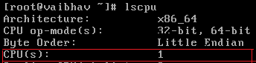

1. Command: less /proc/cpuinfo | grep “model name” | wc -l



# **RAM (Physical Memory):**

* To display total memory(in KB),

Command: free

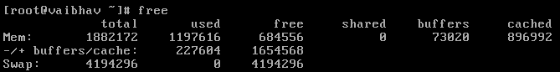

* To display total memory(in MB),

Command: free -m

* To display total memory(in GB),

Command: free -g

* To display **used** memory in **percentage**,

Command: free | grep Mem | awk ‘{print $3/$2 * 100.0}’



* To display **free** memory in **percentage**,

Command: free | grep Mem | awk ‘{print $4/$2 * 100.0}’

